**HONDURAS**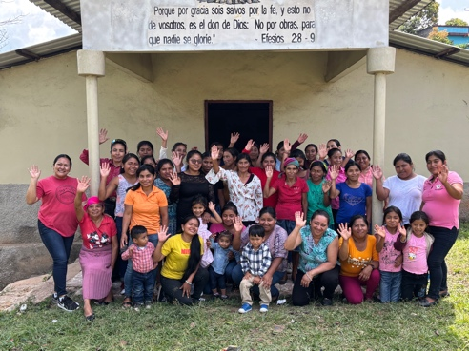

Greetings from Central America, dear brothers and sisters in Christ. We are always very grateful to God and to you for all your support we have received in planting churches among the Lencas in the mountains.

We want to share with you some news and prayer requests. Thank you again for all your support and prayers.

**MISSIONARY WORK IN 2024**

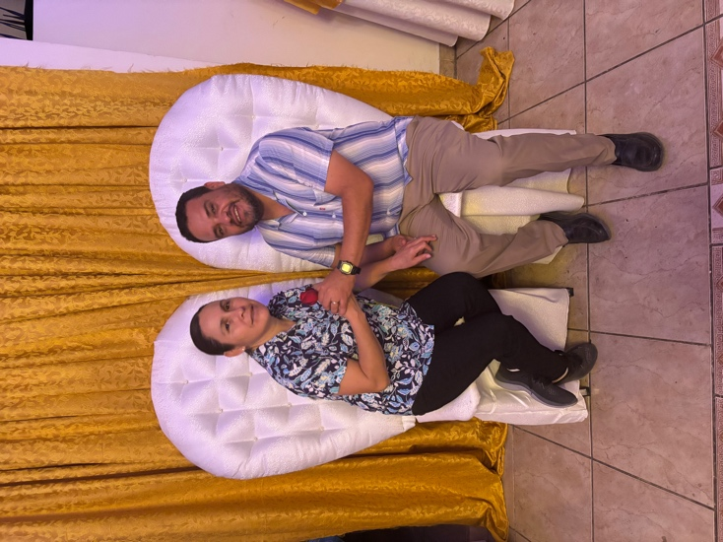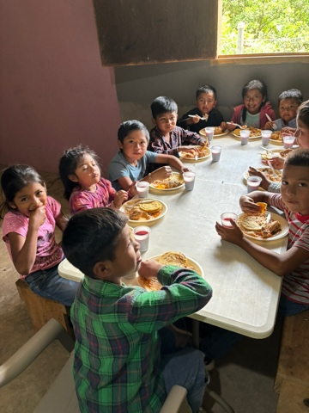I want to share with you information from the different Lenca churches regarding the number of people who joined the Lenca churches in 2024. **128 people received Christ** and joined a local church.

**112 were baptized**. **605 children attended the various Sunday services** in the mountains. Thank you, brothers and sisters, for your support, prayers, and missionary accompaniment.

**YAMARAGUILA CAMP**

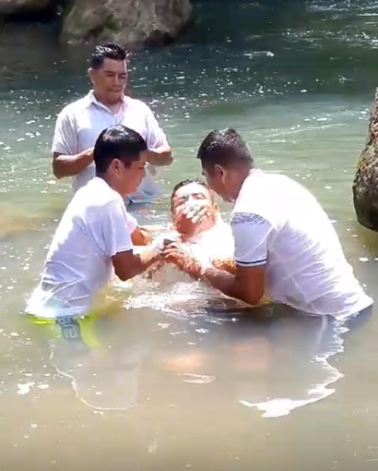We continue working on our training center and camp in Yamaraguila, Honduras. It is a very beautiful place. This time, with the construction of one of the dormitories, which will accommodate 40 people. We also managed to lay the floor for the main building.

This is very useful for training pastors with Bible classes and also for young people in our carpentry school. We have a baptism area that serves all the churches in the region.

**BIBLE CLASSES AND TRAINING FOR WOMEN**

**A KEY ELEMENT IN THE DEVELOPMENT OF MISSIONARY WORK**

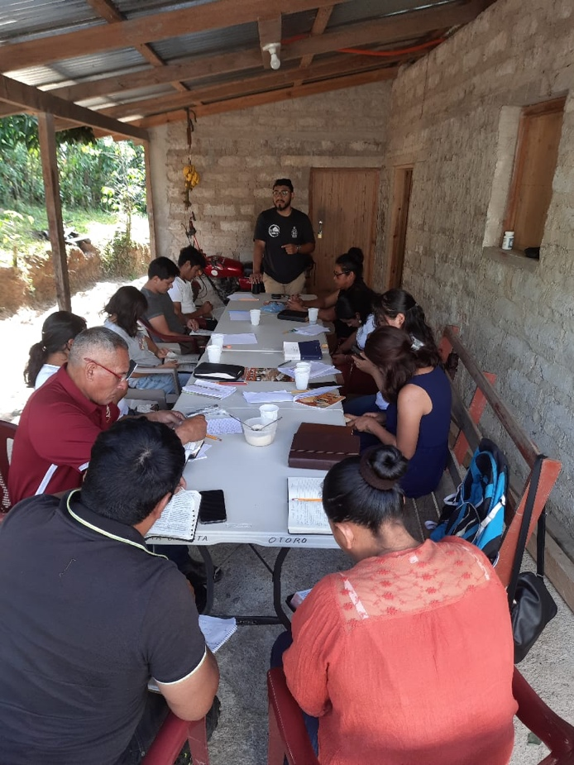

We have our program of monthly meetings with the women leaders of the communities by region, since we have seven different regions in the mountains. They study the Word of God, share their prayer requests, and eat together. It is a blessing every time they meet.

Bible classes are held in the main communities, where believers journey to study together and receive training and discipleship. The development of these programs is a blessing.

**OUR LENCA MISSIONS SLOGAN**

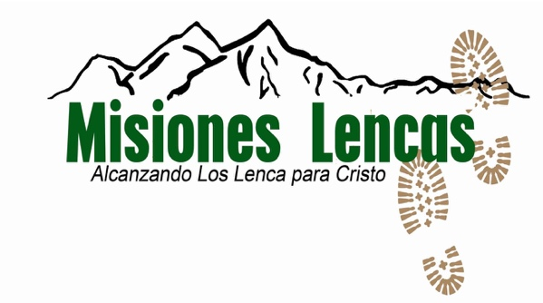

Lenca Missions: Reaching the Lenca for Christ.

This banner reflects what we do: we go to the mountains bringing the gospel to all the Lenca. Our goal: that every Lenca community has a church, a pastor, and leaders who share the gospel.

**OUR DAUGHTER RUTH IS READY TO ATTEND COLLEGE**

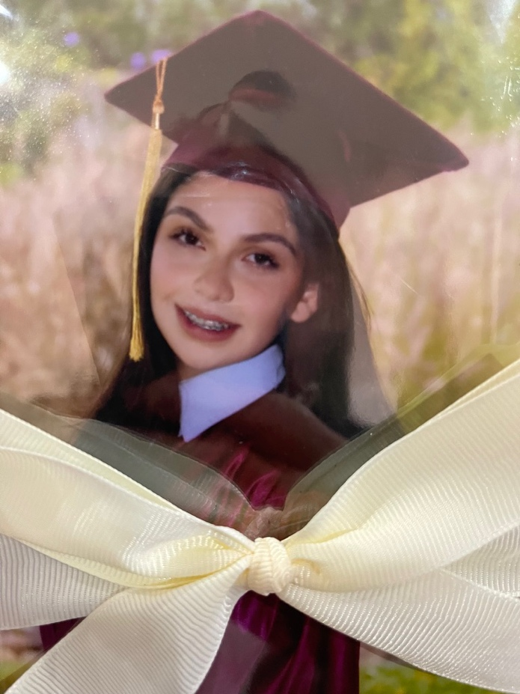

We have been praying for Ruth and her desire to attend a university in America. She was accepted to attend college in North Carolina. We see it as an answered prayer; she will begin in August. She wants to prepare well to return to Honduras with new knowledge that can bring development. Please pray for the student visa process.

Also, pray for her finances. Although we received a scholarship, we still need to complete the necessary funds.

Pray for the transfer from Honduras to the USA.

And for the new relationships she will develop at the university.

Thank you, dear brothers and sisters, for all the support you have given us in our missionary work here. We are very grateful to God and to you. They are very important in the work we do in the mountains.

**PRAYER REQUESTS**

1) Pray for Ruth for her new time at the university, which will begin in August: her transfer and the things she needs.

2) Pray for the Lenca Bible Institute in the different regions, and for the women's discipleship that is developing in the villages. Give thanks for the women who are teaching others.

3) Pray for church planting in 2025, especially for the Opalaca region, which is an area with few churches.

4) Pray for the Lenca camp in Yamaraguila. Pray in thanksgiving for the achievements made and pray for the financial provision to build more dormitories.

5) Pray for Yoamy and her health. She had appendicitis surgery in December. She has now recovered and continues her work with women in the villages.

6) Pray for me that God will give us wisdom to coordinate the work of church planting among the Lencas.

Blessings,

Erick Sanchez

Email: [ericksantic@yahoo.com](mailto:ericksantic@yahoo.com)

Phone: 011-504-9783-5544

www.missionsdoor.org