

Dear Brothers and Sisters in Christ,

We send you our greetings and appreciation.

We share with you the latest news from our missionary field with the Lenca people in Honduras.

Family.
This December, Yoamy has undergone several health tests. Her hemoglobin level has been low, but the worst thing is that she had emergency surgery for appendicitis. She had two days of pain. We had a wrong diagnosis at first, thinking it was some bacteria, but since she had acute pain we decided to visit another doctor who diagnosed appendicitis. Her surgery went well and they administered blood to recover her hemoglobin. Now she is at home in the process of recover; we have been happy because she is progressing very well..
Please keep her in your prayers.

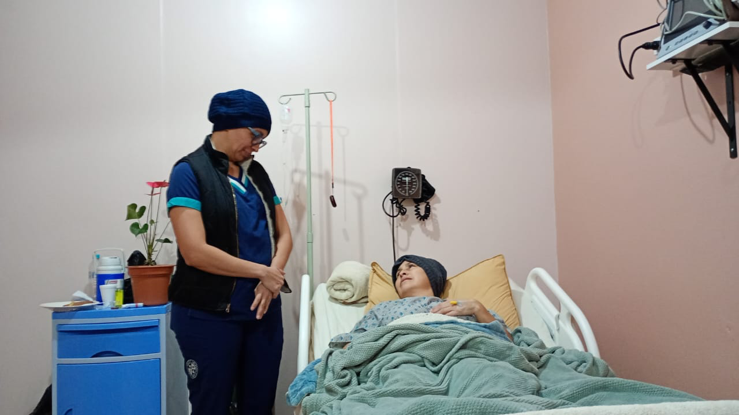

Lenca Economy.
This season is the coffee harvest. It begins in November and ends in February. It is an excellent time for indigenous families to have income and this year we have the best prices in several years. Some travel to pick coffee; others have small plantations.
During this time, the churches do small projects such as buying chairs, guitars, sound systems or repairs in the church. The Lenca economy revolves around agricultural cycles. After this time, there are a few months where there is little paid work and these acquired resources serve to cover some needs of food, education and health. One of the strongest problems is alcoholism.
Pray for the Lenca families and their economy so that they can have wisdom in the management of money and pray for freedom from alcoholism in families.

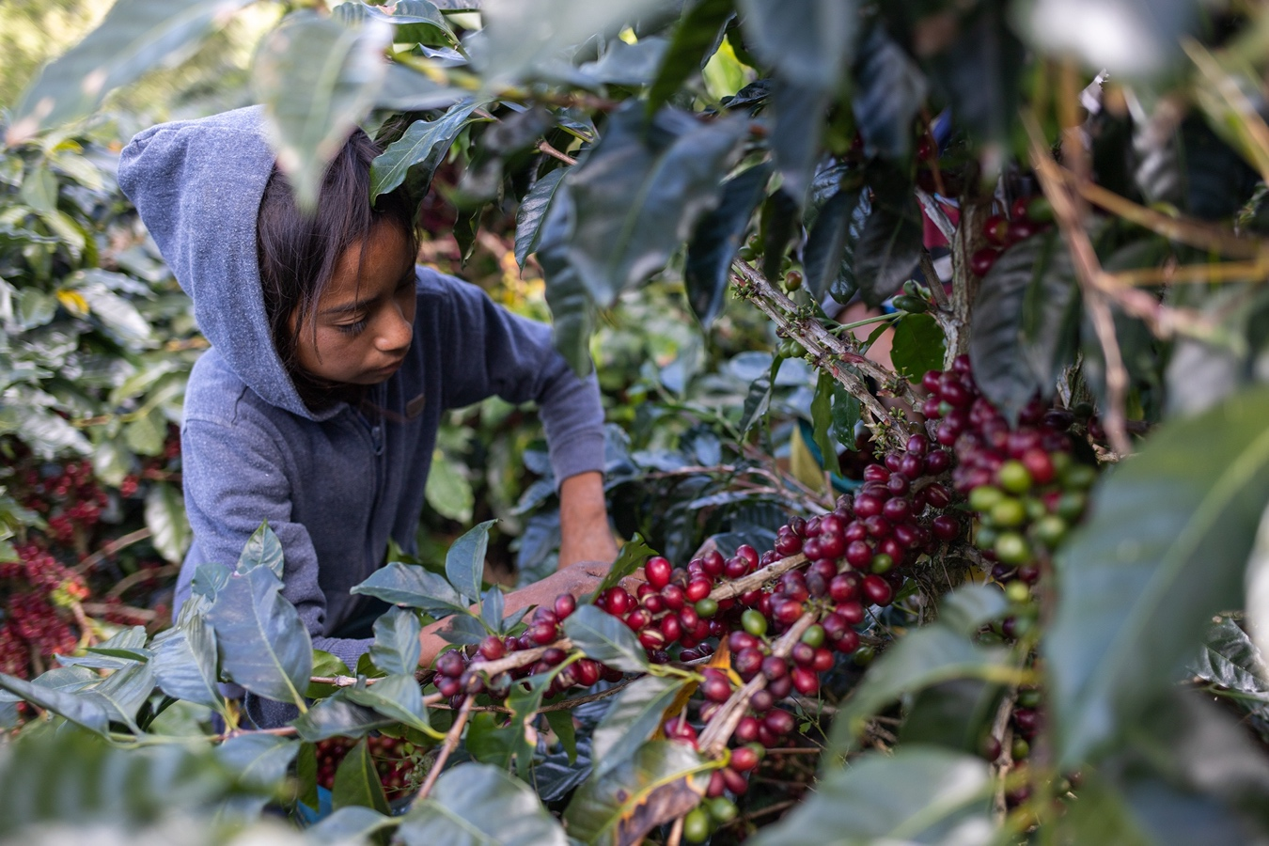

VBS Teacher Training
This season of December and January is vacation for public schools, so it is an excellent opportunity for children's evangelism through VBS. We have done three trainings for the people who will help in this ministry. This year's theme is: God protects his people, the story of Esther.
Pray for this activity that many children and parents or mothers receive Christ. You can sponsor the materials per community; it is around $30.00 each.

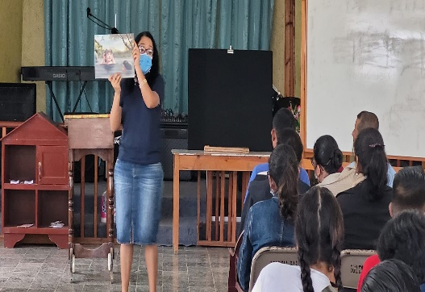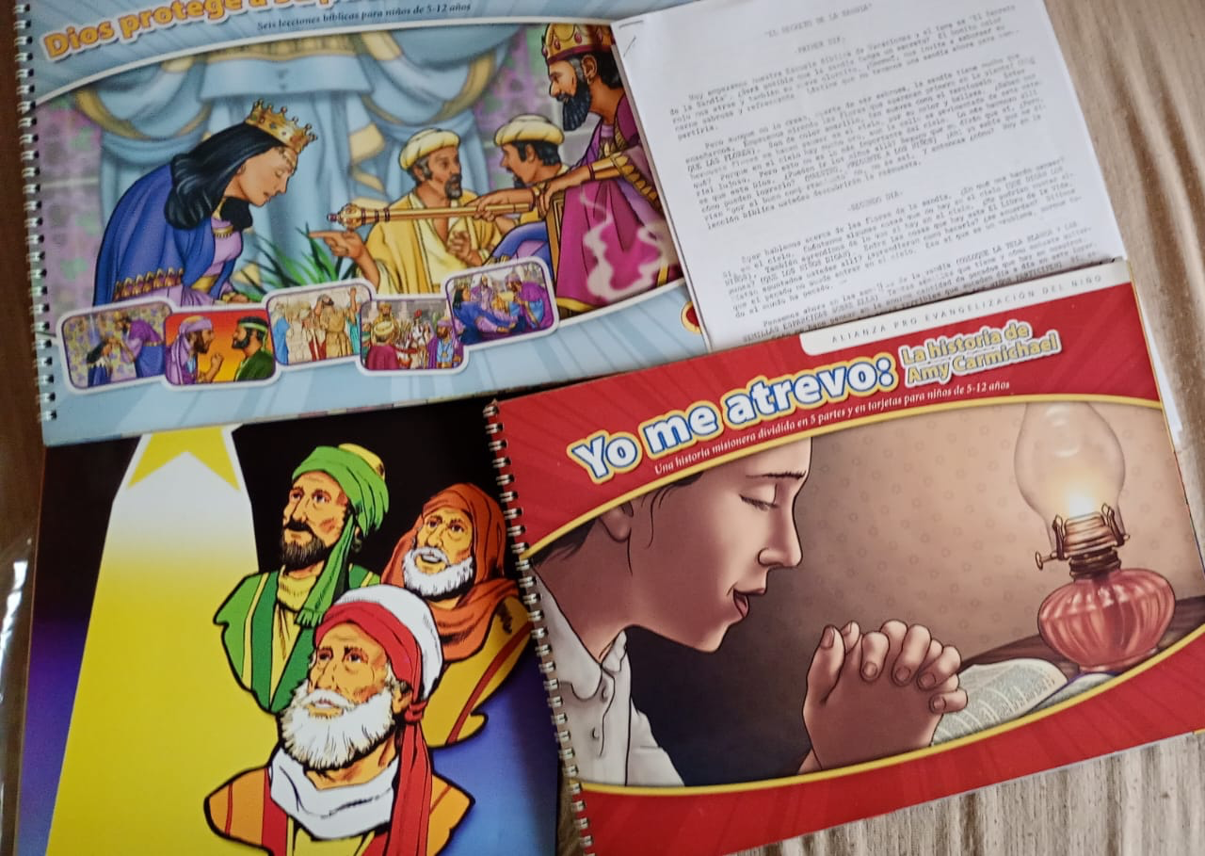

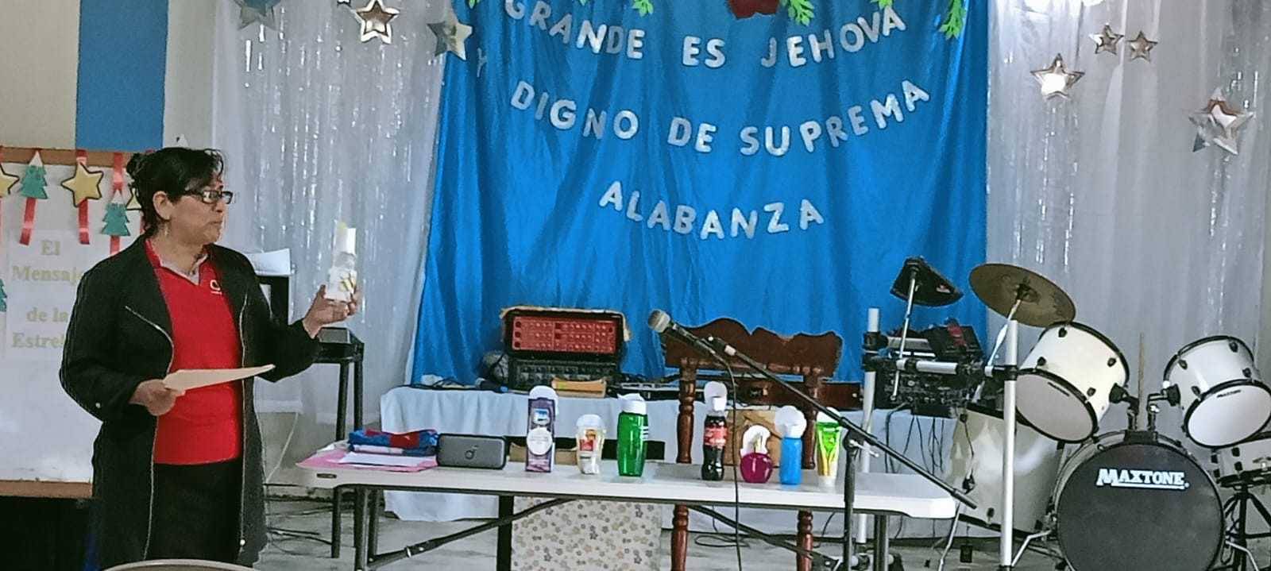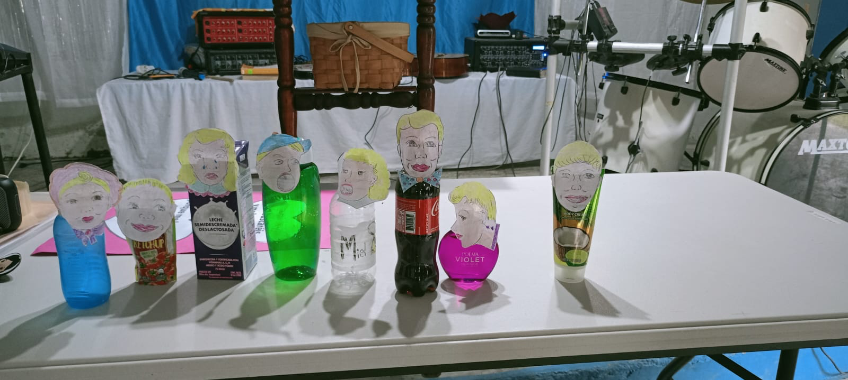

School supplies project.
In February, classes begin again in the schools of the mountains. We want to help some children with their school supplies, especially the children of the Lenca pastors, evangelical workers who go out to preach, and very poor families. It is an excellent opportunity to support this project.

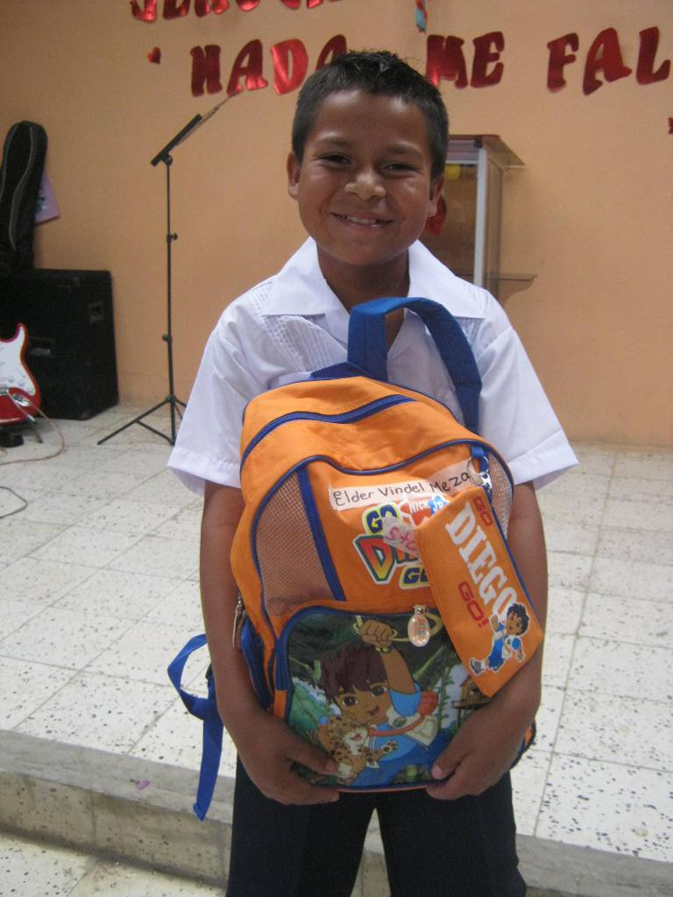

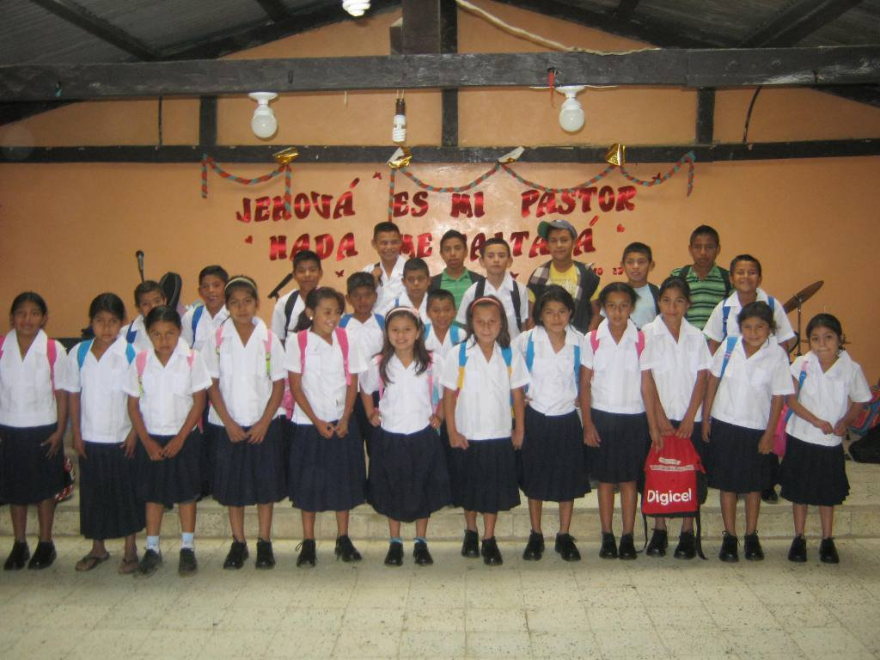

Solar panel project for churches in the mountains

We are very excited about our solar panel project in the churches in the mountains. We have several places that will be a blessing to have this project. It will be very useful because it will allow us to have meetings at night and use other devices that will improve the services. They will also be able to charge their phones.
We will also have activities with the children while we install the panels in the communities.
Thank you to the entire church for supporting this project and coming to Honduras.
Please pray for all the materials in each place.

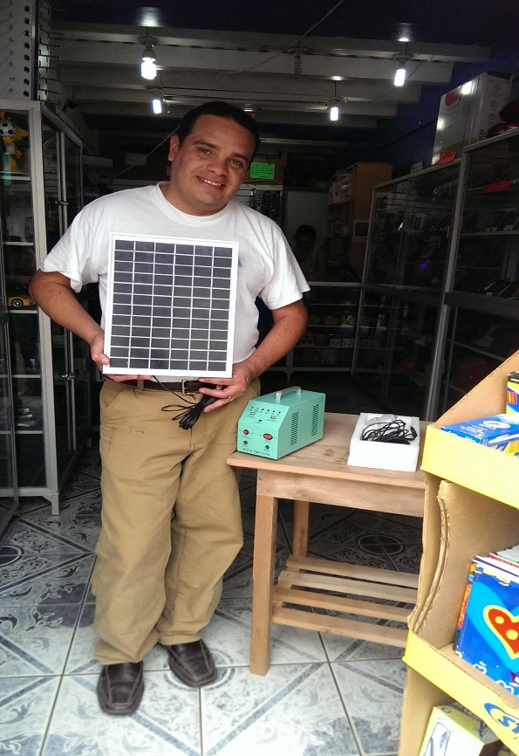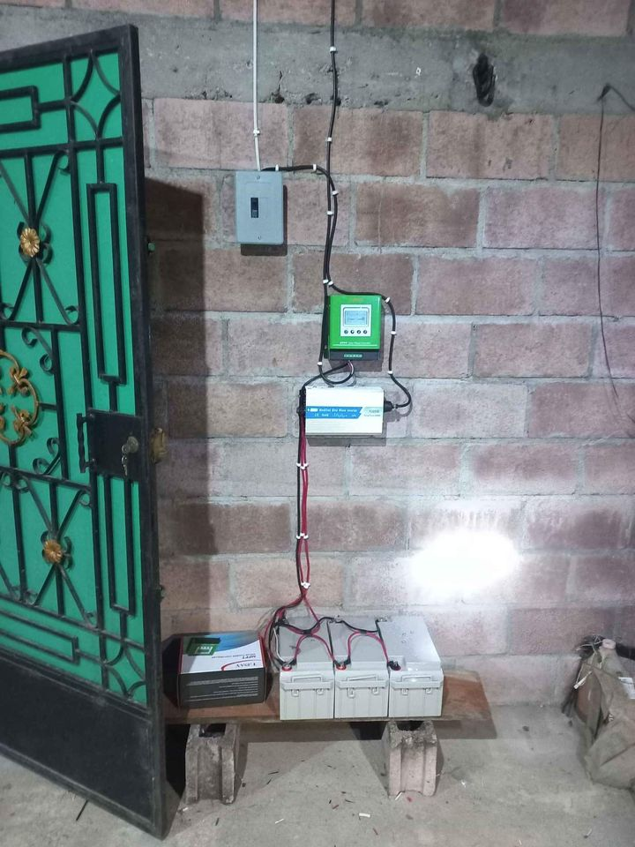

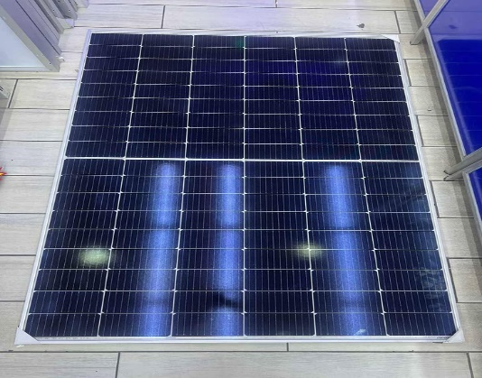

Lenca camp
We continue working in the Lenca camp where we are building the dormitory to accommodate 36 people. We are halfway through the construction process. We need support to buy the toilets for this dormitory: four toilets.

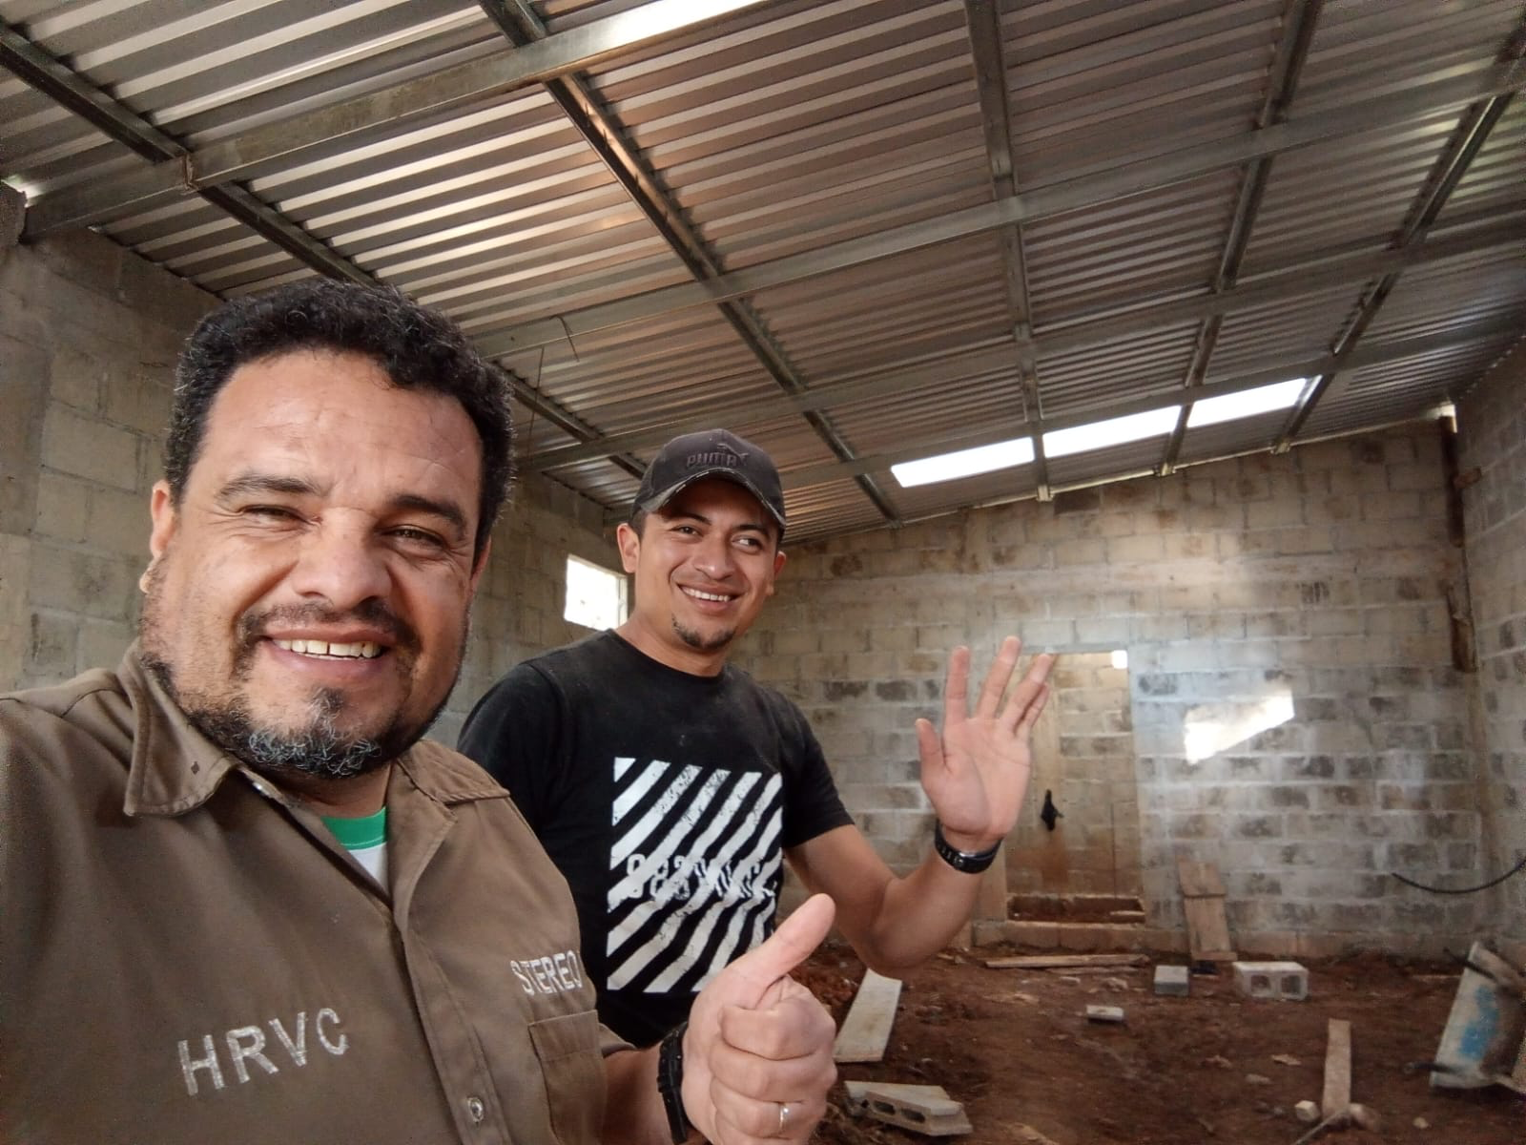

Prayer retreat
Together with the Lenca pastors we will go for three days the first week of January.
Time to pray and seek God in a remote place and put the activities of 2025 in His hands.

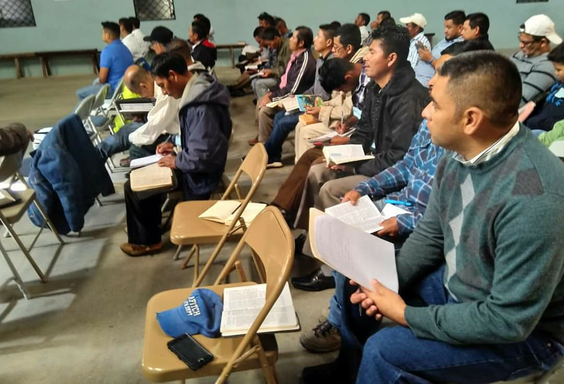

Thank you, Brothers, for your prayers and support. We love you in Christ.

Sr. Erick Sanchez
Phone: 011-504-9783-5444
Email: ericksanchezlenca@gmail.com

