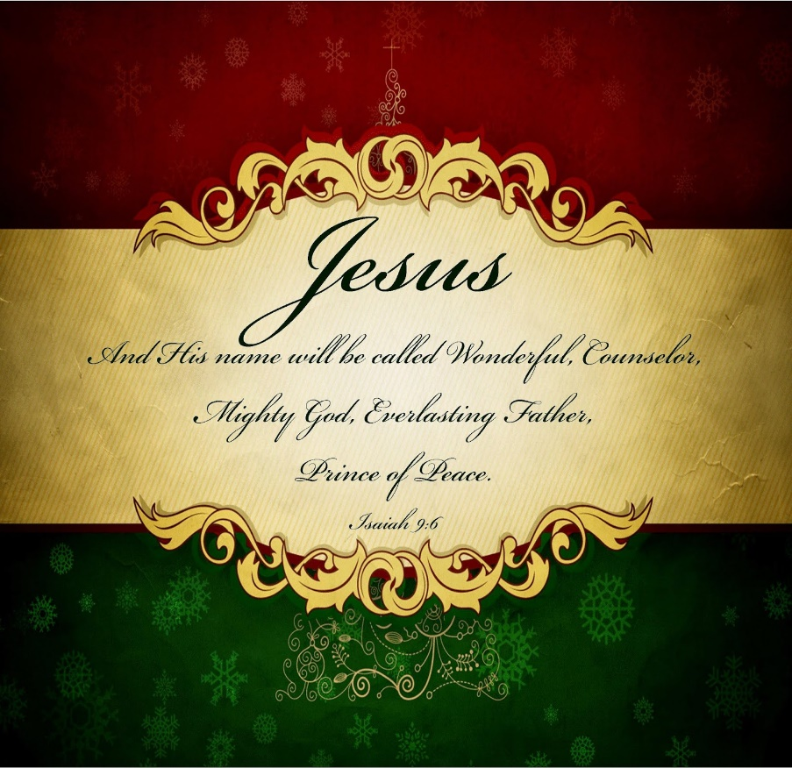

***Christmas 2024***

Dear Brothers and Sisters,

This is our family letter to our spiritual family. We have grown increasingly grateful for you as we reflect back over the past year. And we have so much to be grateful for.

First, after over a year of surgery and powerful treatment, Mary’s most recent tests do not detect cancer. She will continue on a low dose of Verzenio to strengthen her resistance to cancer. This medication costs $14,468 per month, but we qualified for special assistance that covers all of this after our deductible. Thank you **Mighty God**!

Our work with Shepherd’s Heart continues as people seek us out weekly for marriage and relationship counseling. We led a Loving Well marriage course this fall and then met with all the couples after the course for ongoing assistance. Being able to respond to one another in truth and love is dependent on secure attachment to Christ. Without that we are prone to defend, justify and accuse rather than listen, understand, and bring what is needed. We see this in ourselves and in those we meet with. Thankfully, we are securely connected to a **Wonderful Counselor** who guides and directs us.

We are very aware that we live in a world of increasing turmoil and upheaval. Death, destruction, distrust, and unrelenting demands for something more and better abound. This is as true in our culture as it is abroad. We are clearly a dysfunctional society that gives birth to dysfunctional people and that produces dysfunctional leaders and followers. That is why we desperately cling to the **Prince of Peace**. We are reminded of John 16:33: “These things I have spoken unto you, that you might have peace. In the world you shall have tribulation: but be of good cheer; I have overcome the world.”

We recently went to see the movie, “Bonhoeffer.” I (Mark) have long had and appreciated two of his books, The Cost of Discipleship, and Life Together. After seeing the movie (which I highly recommend), I started to read Life Together again. This stood out to me: *“The Christian needs another Christian who speaks God’s Word to him. He needs him again and again when he becomes uncertain and discouraged, for by himself he cannot help himself without belying the truth (that we need the body of Christ).”* This reminded me of how much we have needed our spiritual family and how you have been there for us, encouraging us, praying for us, supporting us, and enabling us to continue. We are thankful recipients of the of the love of the **Everlasting Father** who never ceases to care for his children through the members of his body.

Merry Christmas!

Mark and Mary Bonham