**Erick Sanchez – September 2024**

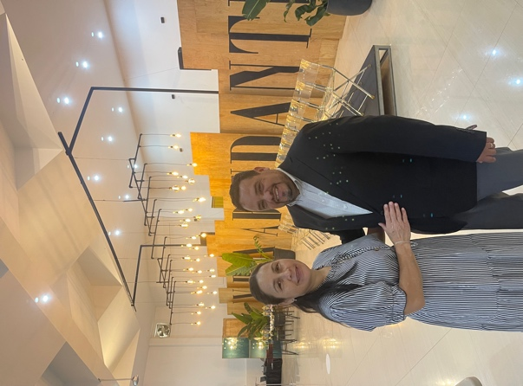**HONDURAS**

Greetings from Central America, dear brothers in Chris.

We are always very grateful to God and to you for all your support that we have received in planting churches among the Lencas of the mountains.

We want to share with you some news and prayer requests.

Thank you again for all your support and prayers.

**LENCA BIBLE INSTITUTO**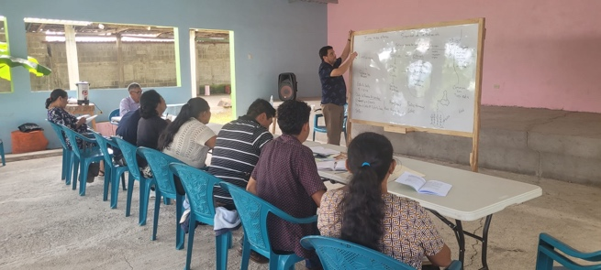

The Bible Institute classes continued with great success. We are studying the Old Testament as a general overview. We thank God that we are seeing more and more of the growth in knowledge and wisdom of our brothers in Christ. We are now planning for two Lenca leaders to travel to study at a more demanding level in the seminary so that when they return they can join the team of teachers and teach the people in their villages.

**LENCA CAMP CONSTRUCTION**

The construction of the camp has continued. Thanks to God and His provision, the dining hall has been finished. Now we are beginning the construction of a dormitory for 36 people and we hope that it will be ready in the next few months. We really long to have four more dormitories like this one to be able to accommodate 130 people in total and in this way be able to train and educate a larger group in the word of 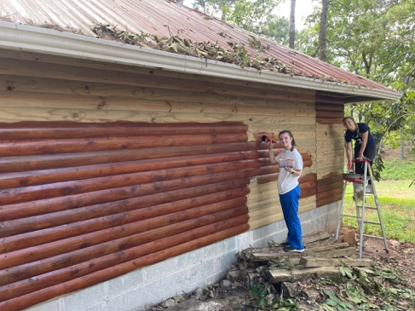 GOD.

**HOUSE REBUILDING A SUCCESS**

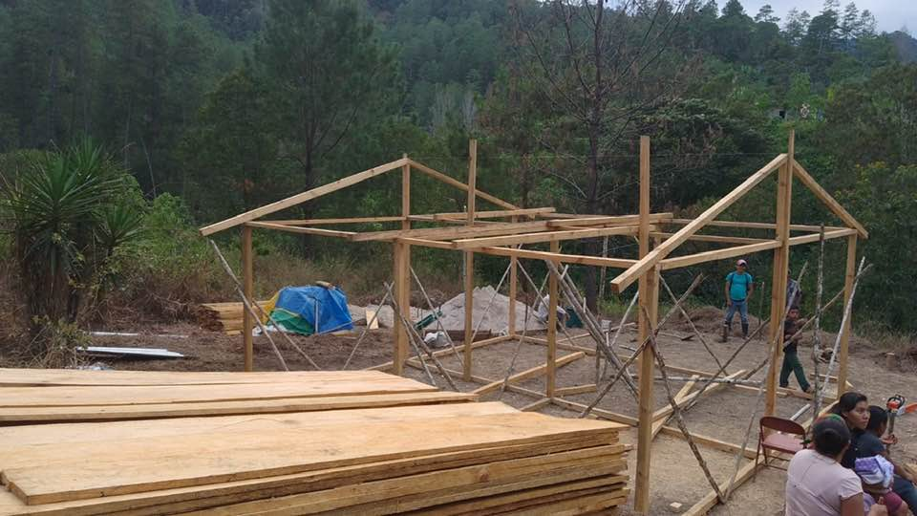

The house that we told you about that burned down in December has been rebuilt with the help of several brothers in Christ. The family is now using it and we thank everyone who contributed a donation to the Lemus family. It has been a great blessing.

**HOUSE TO HOUSE EVANGELISM IN A NEW COMMUNITY WITH A MISSIONS TEAM**

In June we made a visit to the Lenca community of Llano Largo, where we visited the school and the houses for four days. We thank God for the opportunity of evangelism that gave acceptable fruit. Now we have continued with the discipleship process.

Glory to God for those who have become new Christians.

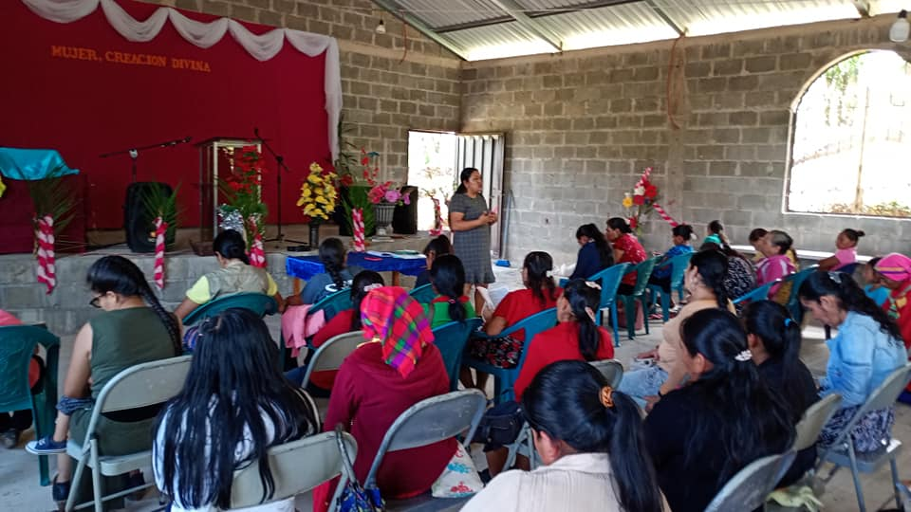

**LENCA WOMEN RECEIVE MONTHLY TRAINING IN THE BIBLE AND CHRISTIAN LIFE**

Yoamy, along with a team of local women leaders, is promoting a 30-lesson discipleship program for women. This has been very well received. The women meet every week to study the Bible. In addition, each month a topic of interest for women is discussed and there is a special time for prayer. Thank God that the women have found comfort and spiritual growth in communion among themselves.

**MY TEAM OF LEADERS**

I have a team of five leaders who work alongside me to plan the strategic evangelism work and the other activities we carry out throughout the year. These leaders live in different regions of the mountains and together with other brothers in Christ promote evangelism and the advancement of church planting.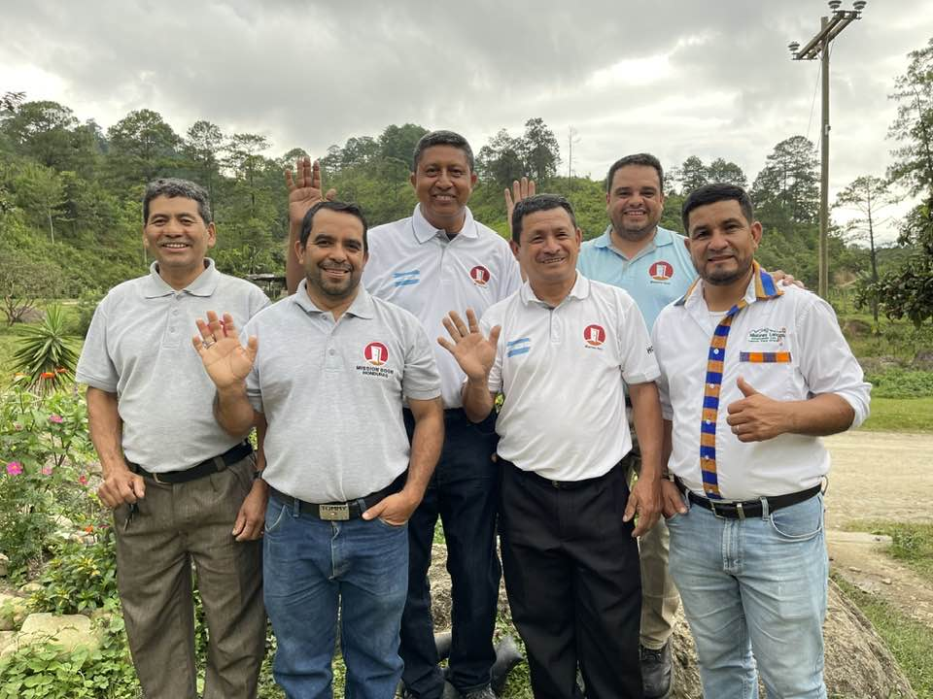

**OUR DAUGHTER RUTH FINISHES HER CLASSES AT SCHOOL**

This July we had the joy of Ruth finishing her studies at school, ending this stage in her life. Ruth is very excited because she will soon begin her classes at the university. She is also a little nervous about this new challenge for her life. We thank God for her and ask that He give her direction in what she chooses to do. Thank you all for your prayers for her.

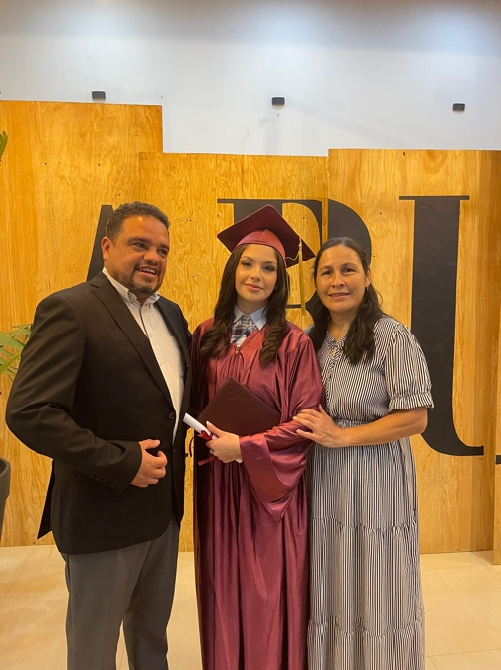**PRAYER REQUESTS**

1) Pray for Ruth that doors will be opened at a university and for the necessary funds to cover her education.

2) Pray for the discipleship of women that is developing. Give thanks for the women who are teaching others. Pray especially for the community of Llano Largo and Arenales where classes are starting a week ago.

3) Pray for the team of pastors who accompany me in the work and planning of everything we do. May God direct us to be very effective and we can do great pastoral work where we are opening new churches.

4) Pray for the Lenca camp in Yamaraguila. Pray giving thanks for the achievements reached; pray for the financial provision to build more dormitories.

5) Pray for Yoamy and I that God gives us wisdom to coordinate the work of church planting among the Lencas.